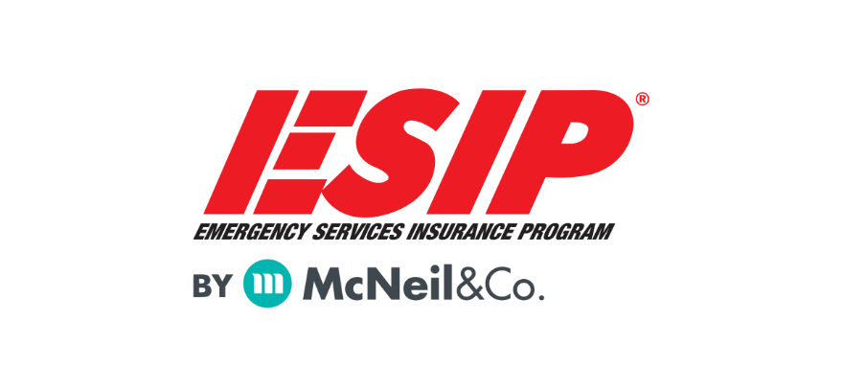

PLAN TEMPLATE FOR EMERGENCY SERVICES ORGANIZATION REOPENING
This information is intended to be a template and guide for fire and EMS response oganizations to establish a phased plan for returning to the “new normal” and more regular business and training operations. Because there is no specific official guidance for our industry regarding the transition, this is a compilation of recommendations based on extensive research by our staff and is, as best as we can define, a best practice for moving forward. We recommend you verify the steps and time frames that are best for your organization based on the unique qualities of your agency and your area or region.
BACKGROUND
Many organizations and businesses have been forced to close down during the mitigation efforts of the COVID-19 Pandemic. As the levels of infection subside in our area, it is our obligation to establish a plan for orderly and safe re-opening of our business and our organizational operations. In an effort to achieve this, [ORGANIZATION] must be aware of the need to ensure safety for our staff, members, patrons and the general public. Our efforts must focus on 4 areas:
- Member screening and safety
- Assuring visitor and public safety
- Assuring minimal chances of virus spread
- Rigorous disinfection of all areas
Each area needs to have a plan for gradual easing of restrictions and rules. Federal and state guidance is referring to a multiple “Phase” plan.
PLAN
Our plan will simulate the 3-phase format of the CDC and federal government. The timing to move from one phase to another phase will be determined by [DESIGNATED PERSON] who will make that determination using all available resources including but not limited to the CDC, State Public Health and local health department resources.
All Phases
- No member may come to work, respond to calls or enter the premises if they are ill or have a recent (within 14 days) exposure to COVID-19
- Every member washes hands upon entry to the facilities. Hand sanitizer and hand washing resources will be made available.
- [ORGANIZATION] will review our leave, attendance requirements and sick time off policies and, where possible, make policy adjustments in order to minimize the impact of members taking time off due to illness.
- [ORGANIZATION] will encourage the use of telework and video conference resources to minimize the density of members in the establishment when it will not negatively impact organizational operations.
- Where possible, we will adjust workspace, living area and common area use to allow for member and public separation at a minimum of 6 feet.
- Promote all persons to utilize frequent hand hygiene as well as cough and sneeze etiquette by providing education, posting reminder posters, and providing ample facial tissues, hand sanitizer, no-touch trash cans and ensuring ample supplies to wash hands at all sinks.
- [DESIGNATED LEADER] or their designee will be made responsible for ensuring all areas of the premises are regularly kept clean and disinfected. [ORGANIZATION] will ensure an adequate supply of disinfectant solutions and protective gear (gloves, masks, etc.) are available to perform required cleaning.
- In an effort to keep members healthy, [ORGANIZATION] will consult with public health and our agency medical officer/physician to determine at what point high risk members (older than 65 and/or have chronic illness) can return to operations and in what capacity. The individual member’s physicians shall also be consulted.
- A log of persons entering and leaving the facilities of the [ORGANIZATION] shall be maintained and all persons shall sign the log with date and time when arriving and departing.
Phase 1 – Minimal organizational access and contact
- [ORGANIZATION] will require all members to be screened for COVID-19 signs and symptoms upon arrival to any facility. Any positive findings will result in the member not being permitted to enter. A record of such screening will be maintained by the organization and kept confidential.
- [ORGANIZATION] will require all members entering the establishment to wear a facial covering. The covering can be a cloth mask, “gaiter” type device or a medical mask. All facial coverings must completely cover the mouth and nose of the person wearing it. Any person not willing to wear an appropriate facial covering will not be permitted on the premises.
- All members will be provided an adequate facial covering. Members are required to maintain the cleanliness and function of any provided non-disposable covering and to report any damage or excessive wear to their immediate supervisor.
- [ORGANIZATION] will make every reasonable attempt to accommodate a member who states in writing they have a medical condition that precludes their ability to wear a provided facial covering. Accommodations may include but are not limited to alternate facial covering options, allowing telework and reassignment.
- No member is permitted to be in the facilities if they have no official business to be there. Any persons “hanging around” will be instructed to leave.
- Visitors, including family and friends of the membership, are not permitted in any organization facility or vehicle.
- Groups of up to 6 may perform practical training evolutions provided all social distancing practices are obeyed. Any type of 1-on-1 training is preferred when appointments can be scheduled (fit-tests, gear inspection, etc.). All participants shall wear a face covering unless it inhibits the activities of the training. Any skill or training operations should be limited to those actions that can be performed with a minimum concentration of personnel. The officer in charge (OIC) of the training will be responsible for following this guideline.
- No business-related travel by any member and all are discouraged from attending meetings. Alternatives such as telephone and video conference should be utilized.
- In the event staff must eat together, every effort shall be made to avoid sharing any utensils or other items that may be touched by others. Members are discouraged from gathering for meals if not required to do so by duty assignment.

Phase 2 – Minor relaxation of restrictions
- All on the premises continue to wear facial coverings. Facial coverings may be removed when wearing one would inhibit performance while training.
- Practical training may be performed in groups as large as 10 but facial coverings and social distancing must still be used. The OIC of the training evolution is responsible to follow this guidance.
- Relaxation of health screenings but [ORGANIZATION] leadership is empowered to require screenings and to send staff home if they appear ill or to restrict staff from working if they experienced recent (14 days or less) exposure to COVID-19.
- No meetings or gatherings in organization facilities of more than 10 people and everyone must obey the “6-foot-rule” of social distancing. If social distance cannot be observed, then the size of the meeting shall be reduced or the meeting not attempted.
- Visitors may enter the facilities after successfully completing health screening and only when wearing an acceptable face covering. Visitors only permitted for official business and no tours are to be conducted.
- Off duty personnel and personnel with no “official business” may be in the facilities in groups less than 10 provided they are obeying social distancing and wearing facial coverings. If food is being consumed, no common utensils or other dinnerware shall be used.
Phase 3– Greater freedom
- When unable to tele-meet, keep groups and public less than 20-30 (as small as possible), consider hybrid tele-meets (maintain 6-foot spread)​
- Small gatherings, dinners and multi-company training​ provided all are obeying social distances and not sharing utensils.
- Facial covering still required when training activities permit
- Use of fitness facilities allowed provided concentration allows 6-foot separation. Every person using the facilities shall thoroughly clean after each use of every fitness tool or device. At [ORGANIZATION LEADERSHIP] discretion the facility will be closed if users fail to comply.
- Hands on training in larger groups permissible when wearing masks and observing separations ​. Limit time and space to keep groups from gathering without a purpose. Recommend still liberal use of video conference for classroom training and developing “hybrid” plans to limit gatherings.

Phase 4– New Normal
This is your organization’s new normal. We recommend you still use facial covering and have aggressive cleaning programs. You may invite visitors to your facilities for tours and public education but be wary that every person can be a carrier of COVID-19 and we still have no treatments or vaccine. Take extra care and recognize your responders are at risk for exposure on every call for help, especially in occupancies with concentrations of elderly or infirm people and other vulnerable populations.

The CDC has released a substantial guidance document that may be useful for guiding your agency:
https://www.cdc.gov/coronavirus/2019-ncov/downloads/php/CDC-Activities-Initiatives-for-COVID-19-Response.pdf
We recommend that you also utilize your local and state public health resources when considering how fast or slow your organization should proceed through its phased plan.

